*Customer* *Retention*

**INTRODUCTION**

Customer retention is a business’s ability to keep existing customers and continue to generate revenue from them. Companies use different tactics to convert first-time buyers into repeat shoppers. In other words, customer retention allows a business to increase the profitability of an existing customer and maximize their lifetime value.

Customer activation strategy involves detailed planning to motivate existing customers to proceed to the next level of their lifecycle faster. It can be for an existing active customer, a dormant customer, customer turning into an advocate, or also for a one-time customer that recently turned into a frequent user.

**Conceptual Background of the Domain Problem Customer**

According to this public survey, Customer satisfaction is an important factor for stores to increase purchase. Some supporting factors are based on site interface, trust and company’s performance ie. Product quality, delivery, benefits and security policies. Research includes factors such as reason for repeat purchase and how loyalty factors influence customers activities. Survey is based on 5 online stores: Amazon, Flipkart, Myntra, Snapdeal and Paytm. We have performed extensive analysis on dataset for customer activation and retention. Customer Retention study is necessary for understanding activities required for reducing the number of customer defections. The goal of customer retention programs is to help companies retain as many customers as possible, often through customer loyalty and brand loyalty initiatives.

**Customer Retention Benefits**

While most companies traditionally spend more money on customer acquisition because they view it as a quick and effective way of increasing revenue, customer retention often is faster and, on average, costs up to seven times less than customer acquisition. Selling to customers with whom you already have a relationship is often a more effective way of growing revenue because companies don’t need to attract, educate, and convert new ones.

**Data Analysis**

* Dataset is imported in csv format.
* This dataset is composed from survey hence, data is not in usable format. The data is still raw and needs proper Data Cleaning and Transformation.
* We need to obtain Site rating, Service rating, customer rating, Time spent by users on each platform, % of users using the platform, % of users recommending the platform for each platform, order cancellation possibility, Drawbacks of the platform, Success rate of user recommending the platform after used, % of potential risk, % of users recommending the platform after using the platform for longest time & % of users recommending the platform after being the most frequent buyer of the platform.
* Usage is a major factor which compares the customers retention rate.
* Lastly, if a user has used all the platforms, then what are his views and recommendations regarding the platforms.

Graphical Representation of data:

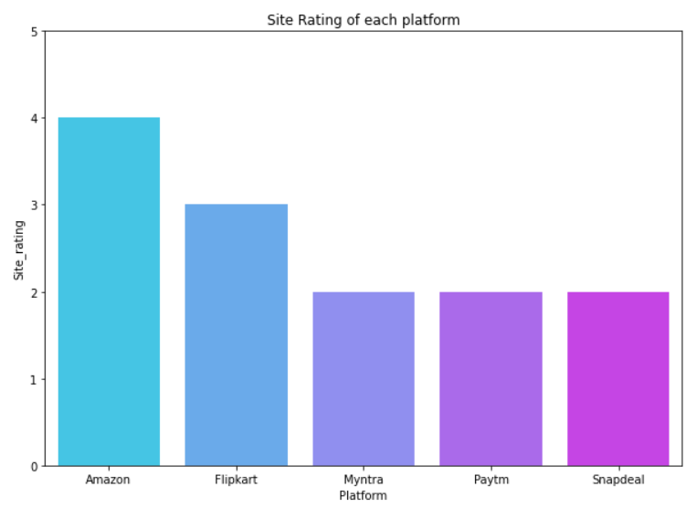

**Insights**:

* This chart represents site ratings of each platform.
* The rating for Amazon is highest.
* The higher the rating, better the chances of retaining customers, new and existing. Amazon stands with an outstanding rating 4/5
* Flipkart next in line having rating 3/5.
* Meanwhile the others have very lower chances of customer activation and higher chances of existing customers leaving based on the rating of their site.

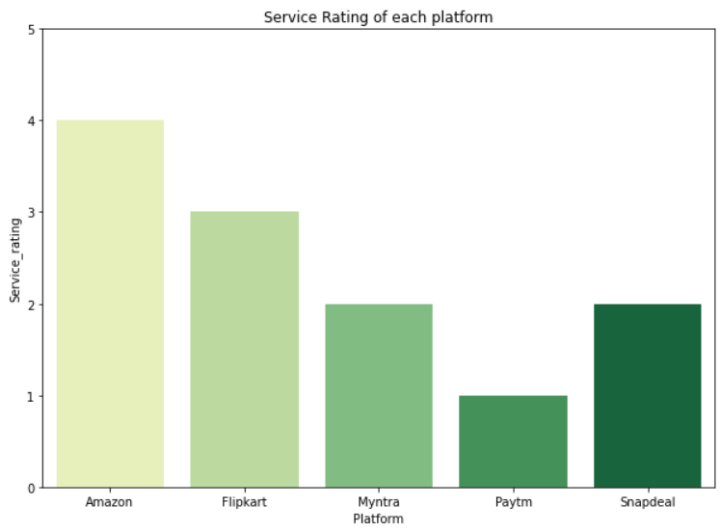

**Insights**:

* Service rating for each platform is based on load time, speed of web and delivery, etc.
* This chart explains highest rating for Amazon followed by Flipkart.

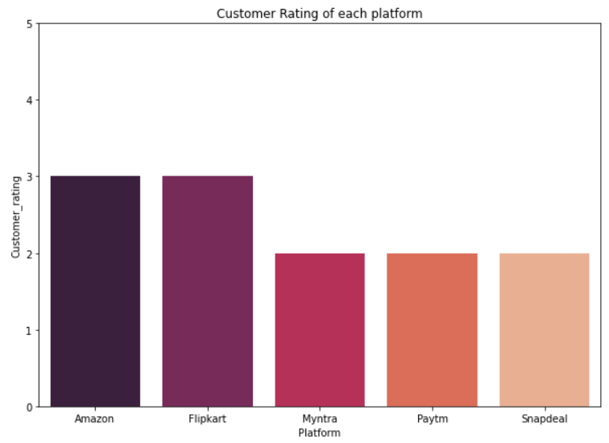

**Insights**:

* Customer Rating chart represents customer satisfaction based on service provided.
* Amazon and Flipkart have 3/5 rating which is highest among all.
* Highest rating explains customer will prefer shopping based on past experience.
* The chances of customer activation and retention is higher in these platforms, meanwhile the others have very lower chances of customer activation and retention, higher chances of existing customers leaving based on the rating of their customers.

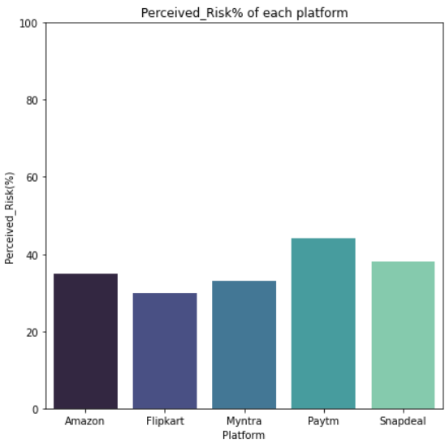

**Insights**:

* Perceived Risk explains the higher the risk%, the lower the chances of retaining an existing user.
* If the risk% is of very value platform can start loose existing customers
* Flipkart has the lowest risk% among all of the platforms. Myntra being the second lowest and amazon third lowest.
* The chances of customer activation and retention is higher in these platforms.
* Meanwhile the others have very lower chances of customer activation and retention, higher chances of existing customers leaving based on the risk%.

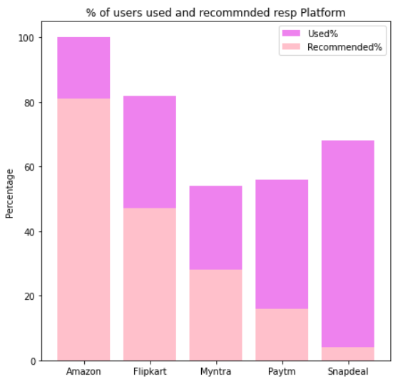

**Insights**:

* Amazon has highest used and recommended by customers.
* Flipkart being next in line with high user percent and recommendations.
* Recommendation is a sign of users’ interest in this platform, the higher, the more activation and retention.

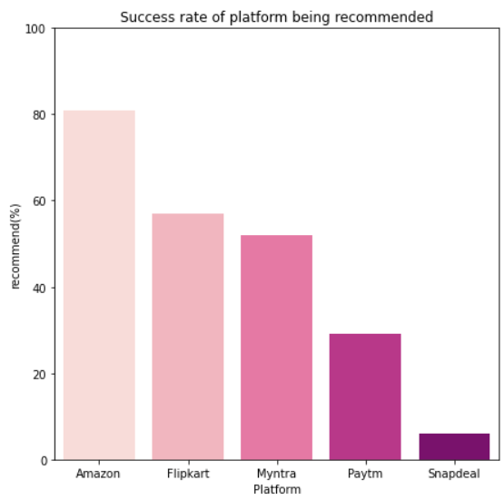

**Insights**:

* Success rate is obtained by getting the percentage of users The higher the Success rate%, the higher the chances of retaining an existing user.
* Amazon, Flipkart and Myntra have more than 50% success rate and hence the chances of customer activation and retention is higher in these platforms.

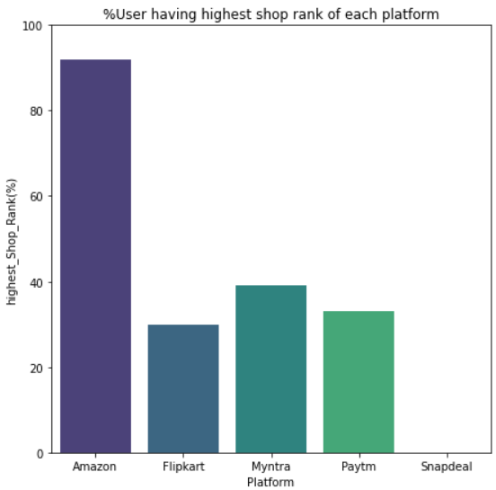

**Insights**:

* Out of the users which recommended this platform, what % of the users have highest shop rank.
* The higher the elite rank, the higher the chances of retaining a user.
* Amazon has an outstanding number of highest shop rank users, the chances for activation and retention of customer is very high.
* Rest don’t even have 50% of such grp in them.

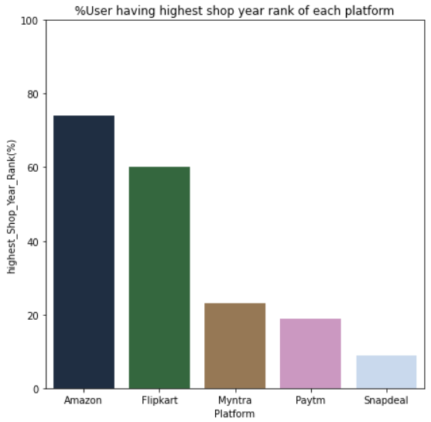

**Insights**:

* Out of the users which recommended this platform, what % of the users have highest shop year rank.
* This shows the credibility of the user recommended, the higher the number the longer has the user used this platform and the recommended it.
* The higher the elite rank%, the higher the chances of retaining an existing user.
* Amazon & Flipkart has an outstanding number of highest shop year rank users, the chances for activation and retention of customer is very high.
* Rest don’t even have 50% of such group in them.

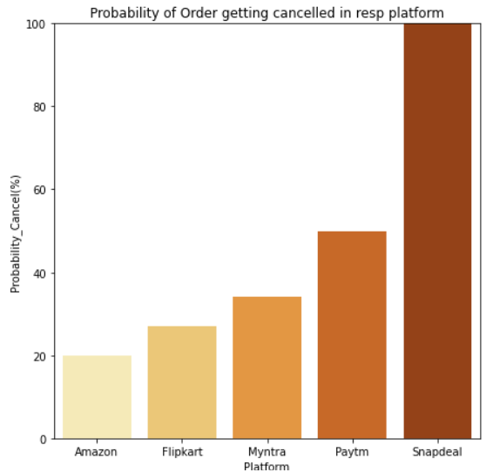

**Insights**:

* Cancel rate% is an important factor for customer retention
* The higher the Cancel rate%, the lower the chances of retaining an existing user. the increasing number also shows us the decreasing interest of a customer to buy from this platform.
* Amazon has the lowest cancel rate, then Flipkart and Myntra, rest all have more than 50% cancel rate and hence the chances of customer retention is lowest in these platforms
* The lower the cancel rate the better for company

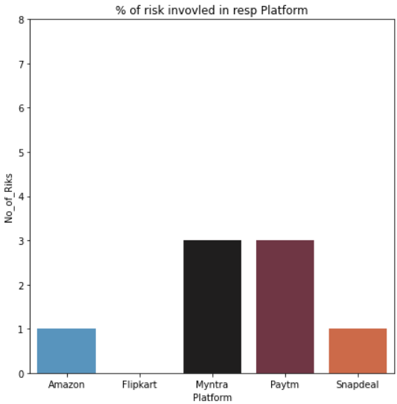

**Insights**:

* This graph gives us the number of drawbacks a platform has.
* The more the drawbacks the lower the chances of activation and retention of the customer.
* Flipkart being the one with no drawbacks and then Amazon and Snapdeal with one drawback
* The lesser the drawbacks, the better.
* Customer activation & Retention is inversely proportional to this number.

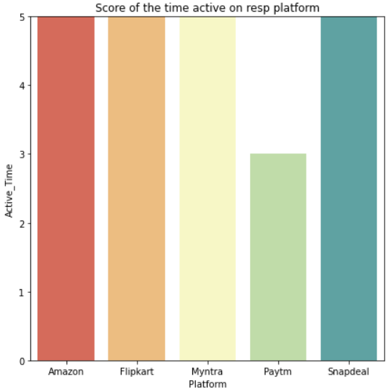

**Insights**:

* This graph gives us the time spent by a customer on the platform.
* The higher the number, the more the interest of a user to shop online from specified platform.
* Except for Paytm rest all have users spending most time for online shopping.
* The higher the number the more customer retention and more the activation.

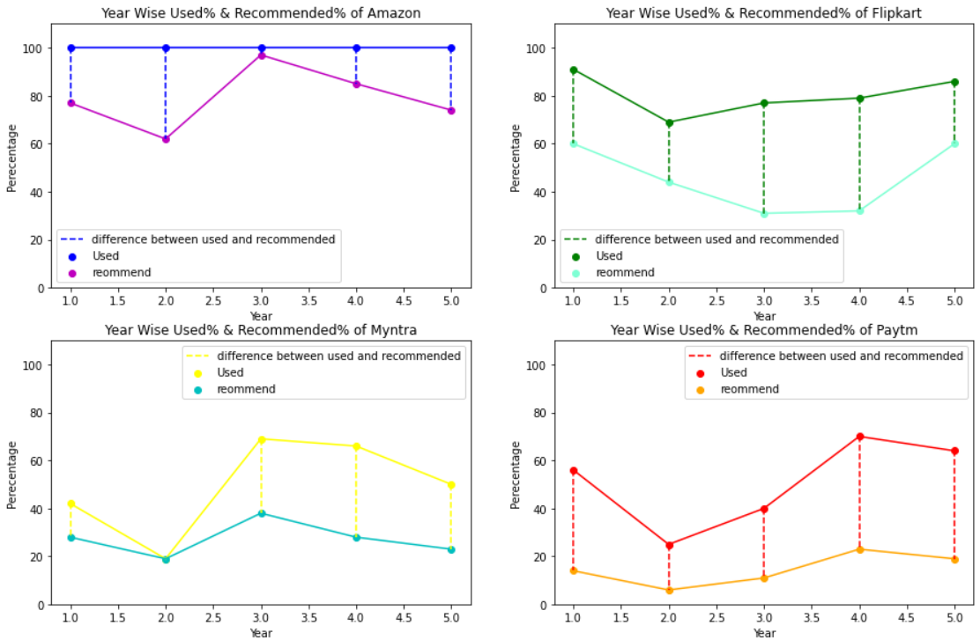

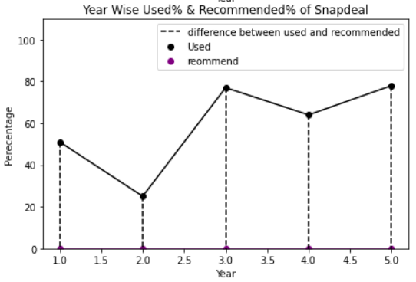

**Insights**:

* Year Wise Used% & Recommended% of every platform.
* From above graph we can check the % of users used the specific platform for every year rank and recommended the platform.
* We can deduce that as years progress how well is the customer retention and activation
* From above we can deduce that the users recommended for amazon is higher than the used% of users
* Hence the user activation of amazon is higher than any other platform.
* In this manner we can deduce users activation and retention of every platform year wise.
* To check retention we shall check the used and recommended % of every platform of year rank1 and year rank 5.
* Our goal should be to reduce the gap between the used% and recommended% of every platform, for better activation and retention.

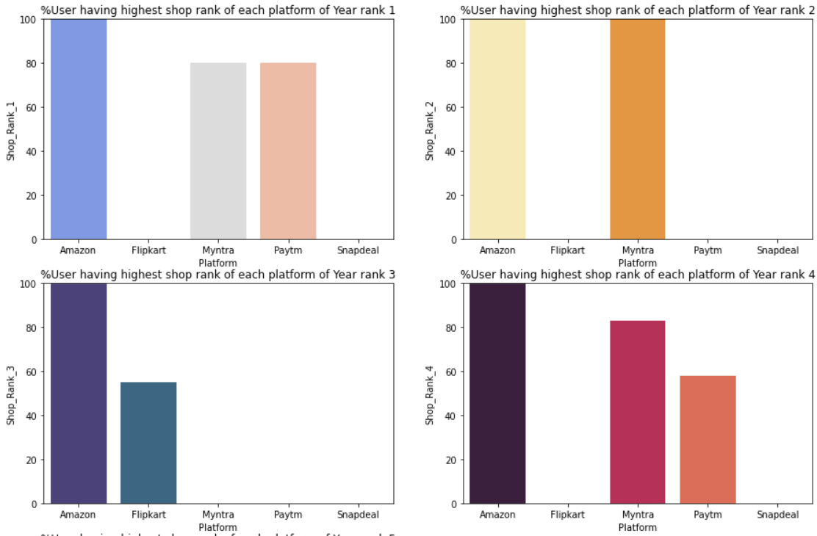

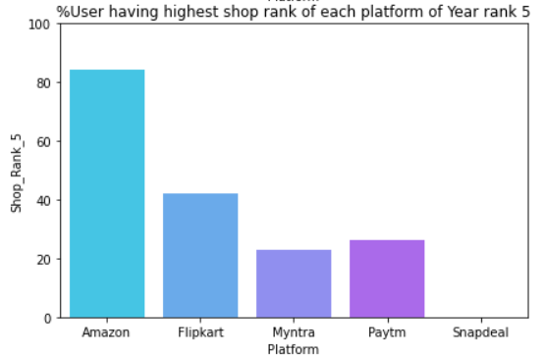

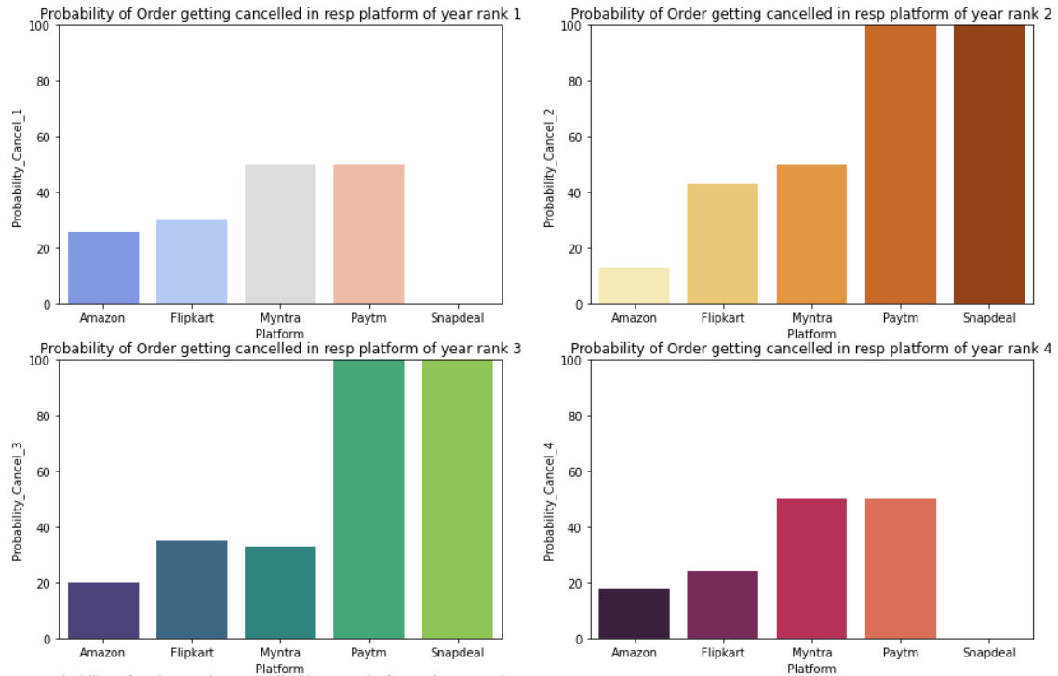

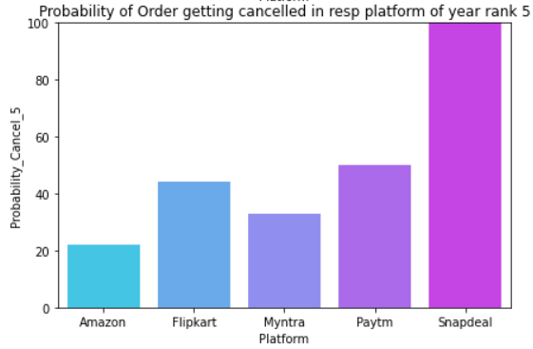

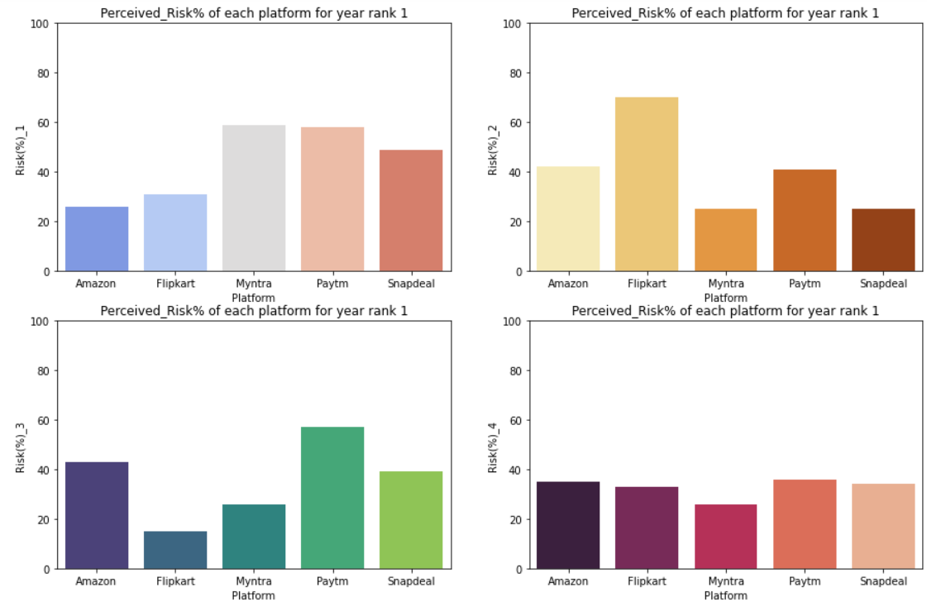

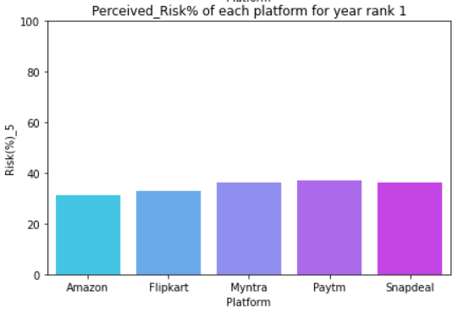

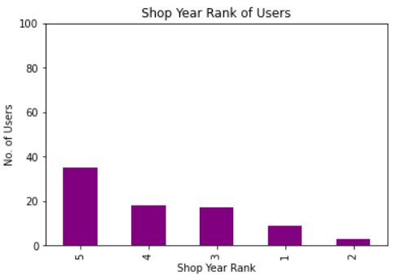

* The graph is to display shop year rank for a user who has used all the platforms available.
* Shop year rank of highest rank is attained when all platforms are used.
* Meaning when a user uses all the platforms, he will be continuing with online shopping for longer period of years.

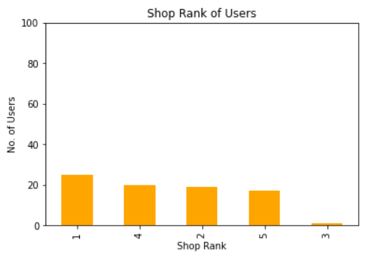

* The graph is to display shop rank for a user who has used all the platforms available.
* Lower shop rank is obtained when a user uses all platform.

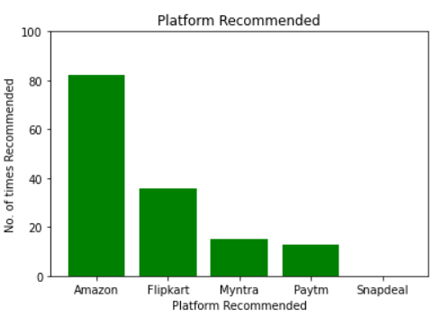

* We can see that when user has used all the platform, he is never recommending Snapdeal.
* Amazon & Flipkart are most recommended.

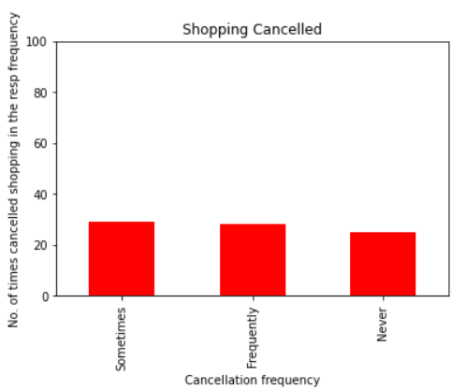

* When a User uses all the platform his cancellation frequency also decreases.
* Good chance of an order never being cancelled or being cancelled very few times.
* In comparison to the combination of never and sometimes cancellation frequency, frequent shopping cancellation is less.

**Conclusion**

* Amazon and Flipkart are most used and recommended platforms.
* These platforms have higher rating in every terms.
* These platforms have lower risk%, lesser drawbacks and less cancellation chances of an order.
* These platforms have high percentage of elite group with good credibility using and recommending the platform.
* Out of these 2, Amazon is the one which has higher chances of customer activation and recommendation.
* Rest all platforms should be improved or their existing users are going their platforms.